Sagicor Sigma Corporate Run/Walk 2017

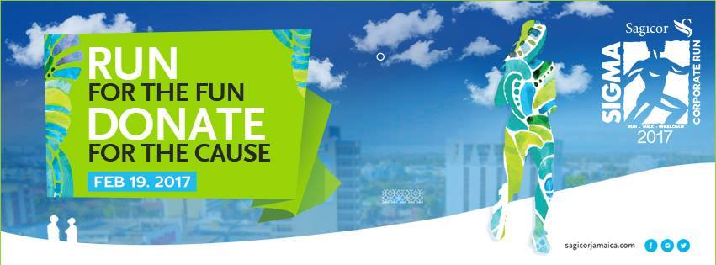

The Sagicor Sigma Corporate Run/Walk and Wheelchair road race has become a highly anticipated event on many Jamaican corporate calendars each year. Understandably so, it is an event that pulls thousands of walkers, joggers and competitive runners to get some exercise, and loads of fun while supporting a worthy cause.

For the first time, the Finance and Banking student cohort would participate in the 19th staging of the Sagicor Sigma Corporate Run/Walk on Sunday, February 19, 2017 at 7:30AM,

It was an exciting experience, as warm up commenced at 6:45AM and participants would line up before the starter on Knutsford Boulevard. For some the walk/run would test fitness levels, as shown in the varying finishing times, which culminated at the Emancipation Park, on Oxford Road.

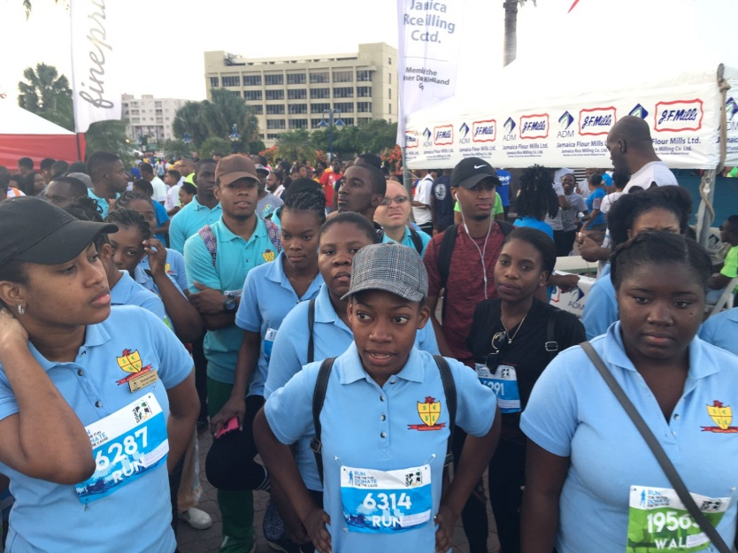

Of course Sigma Corporate Run/Walk is focused on providing support to health and child related initiatives in Jamaica. As expected, our group was eager and felt privileged to contribute to this cause. This event would also serve as our second outreach event. This year, Sagicor’s $60 Million target, would provide funding to children of the Bethlehem Home for Abandoned Children (Operated by Missionaries of the Poor), the Spanish Town Hospital Special Care unit and the Mandeville Hospital Neonatal Intensive Care.

The Finance and Banking Seminar 2016/2017 is in full support of this annual event and has left this as a legacy for the other groups to come. Participating in this event each year, will definitely ensure our part is played in the development of our nation’s health and child care.

Until next year!

Vickacia Williams